SolarAgent Pro Design & Planning
Architecture diagrams, UI wireframes, and GitHub Projects board configuration, building on the Week 1 SRS (Section 1.6, Table 1.2).

1. Data model (ER diagram)
The v1 session store (in-memory, per NFR-2) holds one Session per user visit, linked to the site input, appliance loads, and the results each engine produces. This is the schema a future persistent store (Epic E9) would implement directly.
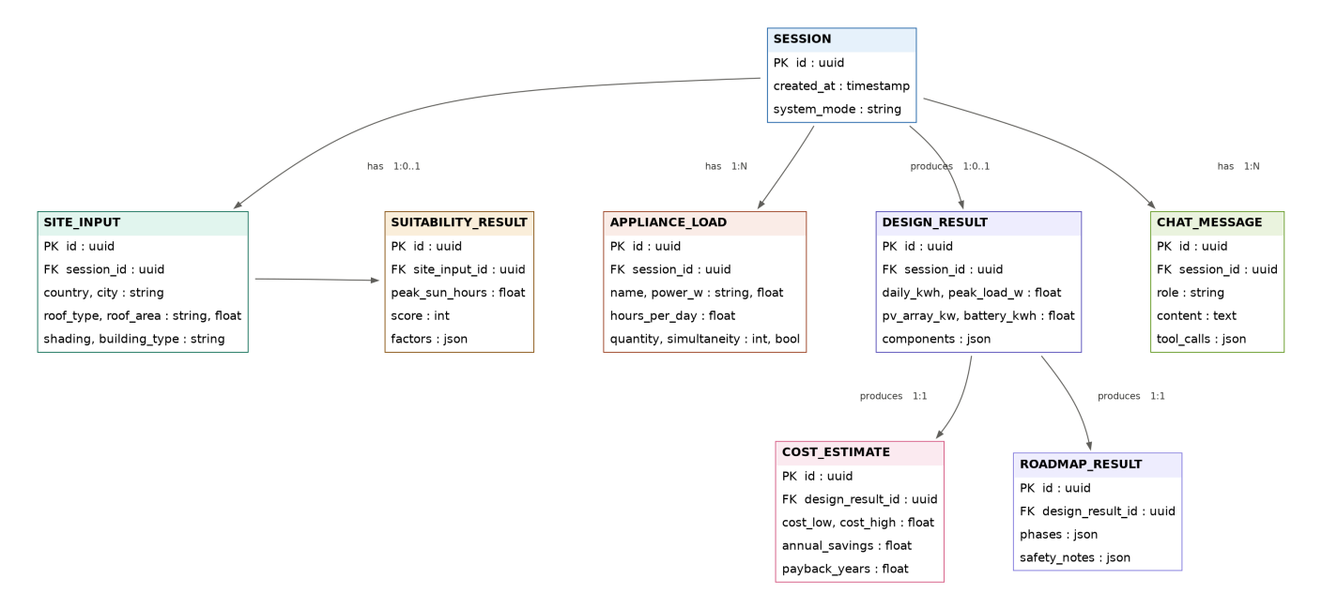
Figure 2.1 — Entity relationship diagram for the SolarAgent Pro session data model

Notes
- SESSION is the aggregate root; every other entity carries a session_id foreign key, matching the current SessionStore design.
- SUITABILITY_RESULT, DESIGN_RESULT, COST_ESTIMATE, and ROADMAP_RESULT map directly to the outputs of FR-1 through FR-6.
- CHAT_MESSAGE.tool_calls records which engine(s) the agent invoked for that turn, supporting the FR-7 traceability requirement.

2. Request flow (architecture)
Two flows share the same engines: the linear form-driven path (site -> load -> design -> cost -> roadmap -> dashboard) and the conversational path, where the agent calls the same engines as tools rather than duplicating their logic.
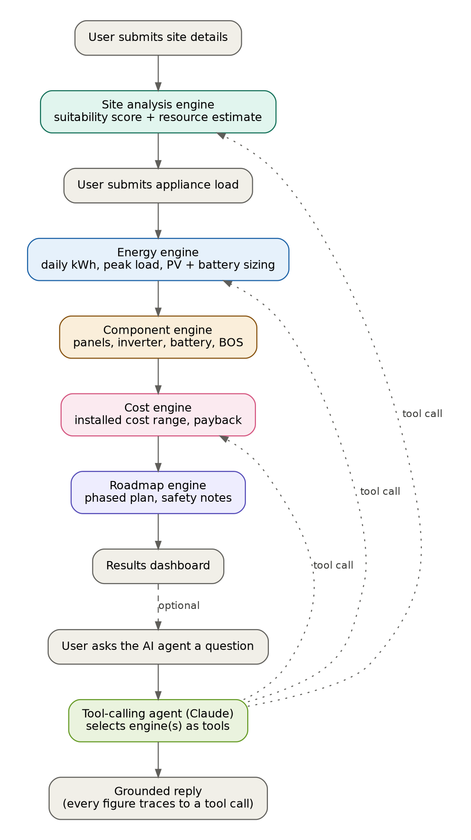
Figure 2.2 — Request flow through the five engines and the tool-calling agent

3. UI wireframes

Results dashboard
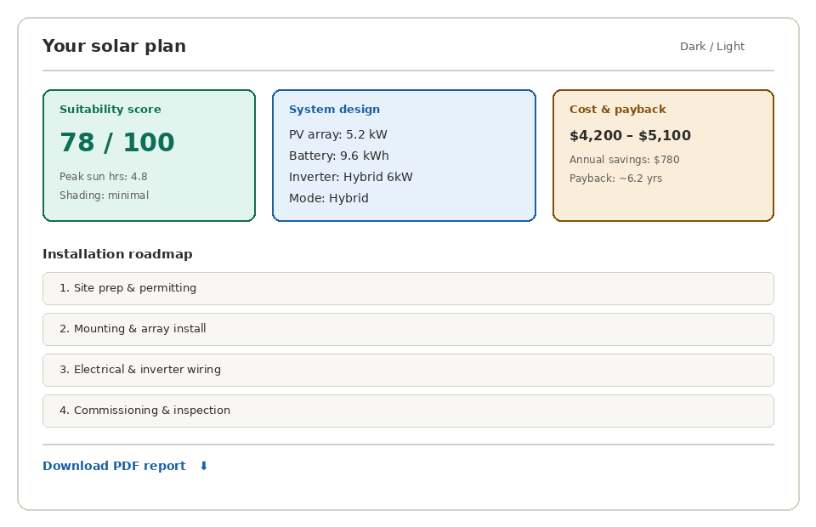
Figure 3.1 - Results dashboard wireframe
- Suitability score, system design, and cost/payback shown as three summary cards
- Installation roadmap as an ordered phase list below the summary
- Report download action, dark/light toggle in the header

Chat panel
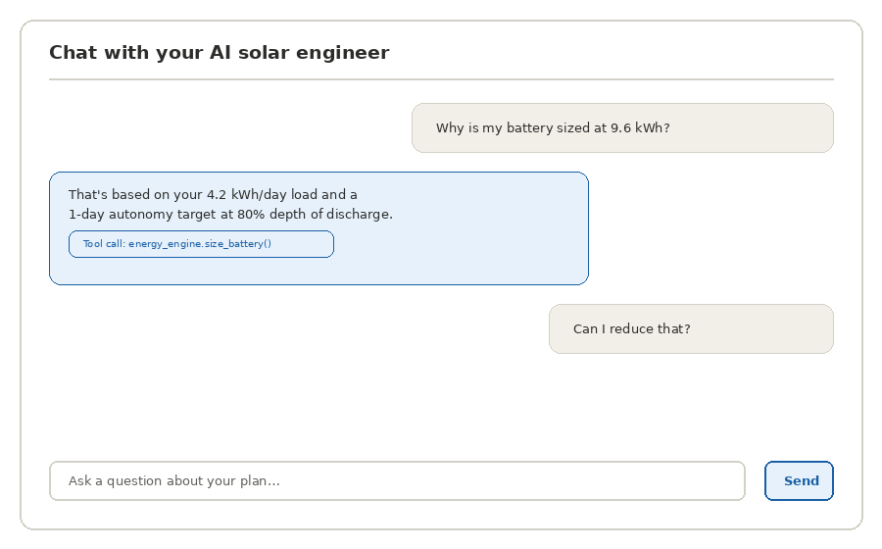
Figure 3.2 - Chat panel wireframe
- Chat bubbles distinguish user vs. agent turns
- Agent replies show a tool-call chip when a figure is grounded in an engine call (FR-7)
- Standard text input + send action

4. GitHub Projects board configuration
Columns: Backlog -> Ready -> In progress -> In review -> Done.
Labels: engine, frontend, agent, docs, infra, bug, week-2, week-3-4, week-5-6.
Views: board grouped by status; table grouped by epic for traceability back to Section 4 of the SRS.
Seed backlog (from the Week 1 SRS Section 4 epic list):
Epic | Task | Priority | Status
E1 | Site analysis engine | High | Done
E2 | Load & sizing engine | High | Done
E3 | Component & cost engines | High | Done
E4 | Tool-calling conversational agent | High | Done
E5 | React frontend (forms, dashboard, chat) | High | Done
E6 | PDF/HTML report generation | Medium | Done
E7 | UI wireframes & architecture diagrams | Medium | In review
E8 | GitHub Projects board configuration | Medium | In review
E9 | Authentication & persistent session store | Medium | Backlog
E10 | Live weather API integration | Low | Backlog
E11 | Automated test suite for engines | Medium | Backlog

E7 and E8 move to Done once this document and the board itself are committed. Automation: any issue labeled week-2 is auto-added to the board; issues close automatically when their linked PR merges to main.

